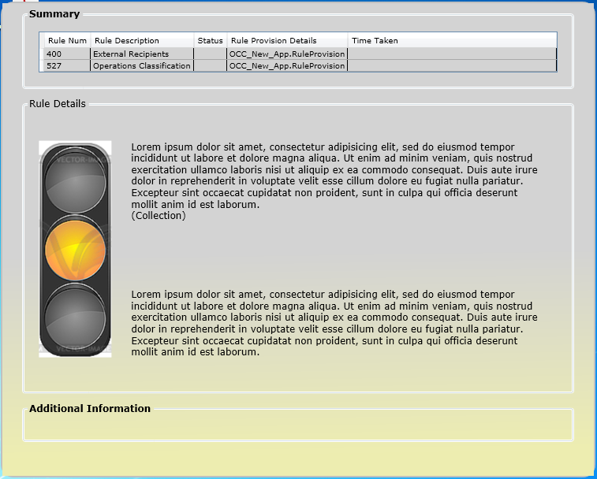**Final UI**

|  |  |
| --- | --- |
| **User Control 1 SummaryView.xaml** |  |
| **User Control 2**  **Rule1View.xaml** |  |
| **User Control 3**  **InformationView.xaml** |  |
| **Main Window**  **MainWindowView.xaml** | Transparent Window where all the user controls are called |

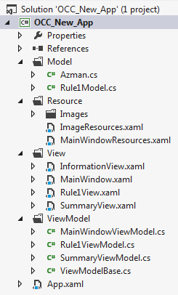**Architecture** 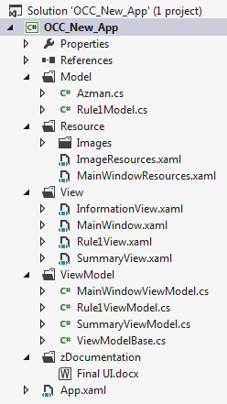

Templates

SummaryView (xaml)

Bindings

Commands

Styles

SummaryViewModel (cs)

Azman (cs)

Templates

Rule1View (xaml)

Bindings

Commands

Styles

Rule1ViewModel (cs)

XML from Kapil (cs)

Templates

Rule2View (xaml)

Bindings

Commands

Styles

Rule2ViewModel (cs)

XML from Kapil (cs)

Communication   
MainWindowViewModel (cs)

Templates

InformationView (xaml)

Bindings

Commands

Styles

InformationViewModel (cs)

UserDetails (cs)

* **Resource Folder –** will have all the resources used across pages
* **Converter Folder –** Will keep a list of all converters in the file

**Next Steps in POC**

1. Working model to have View Models communicate with each other
2. Using Multithreading (Dispatcher) to keep updating the middle part of the alert
3. Using triggers to update the shade of the MainWindow – so yellow shade when softblock and red when hardblock
4. Create DataAccess and Data Layer – so WPF reads and displays UI from an XML (versus hardcoding in constructor)
5. UI enhancements – to make it look professional

Completion of all these steps – should showcase a fully working and correctly architected (hopefully) WPF sample which we should then look to incorporate in our main project (Kapil’s OCC concept project)